**CHAPTER 1**

**INTRODUCTION**

In recent studies, the World Health Organization (WHO) reported that about 15% of the world's population suffers from a form of disability, half of which cannot afford health care [1]. Due to various political, economic, scientific, and demographical reasons, the overall rates of amputees and limb dysfunction patients are increasing [2]. There are over 10 million amputees worldwide, out of which 30% are arm amputees [3]. Although prosthetic limbs exist since decades, they are not very natural in terms of operation and interaction with the environment. They require undergoing an invasive surgical procedure [4].

The main goal of such complex procedures is to reassign nerves and allow amputees to control their prosthetic devices by merely thinking about the action they want to perform as stated by the John Hopkins Applied Physics Laboratory. A team at the John Hopkins University developed a robotic arm in their physics lab that is controlled by brain signals [5]. The arm has 26 joints, and can lift up to 45 pounds. It is based on an idea, which can be altered to fit any need, from someone missing just a hand to an entire limb. Engineers from Ossur, one of the biggest bionic arms markets in the world, designed an artificial bionic advanced leg and it was tested on a farmer who lost a leg [6]. A comparison was made between the bionic and the mechanical artificial legs, in which the engineers noticed some flaws in the mechanical leg, and thus causing the user to fall while walking if wrong amount of pressure was applied to the toe where the leg is connected. The bionic leg, on the other hand, was constructed out of more than one piece. The knee, the foot and the leg were assembled to create a fully functional bionic limb [7]. This limb has a brain of its own, and can sense what surrounds it by the processors that analyze the inputs. According to the head of this group of engineers, the leg costs more than a few sedan cars.

Prosthetic limbs need to be measured and fitted to the patient for his needs [8]. To apply prosthetics on a patient, intense medical observation and a training course for the patient are needed so that he can use the limb comfortably. There are several techniques used as a means of controlling robotics arms, and the top three methods are highlighted hereafter. The first method is to use an electroencephalogram (EEG) device [9], which will record the person’s brain waves when he is thinking of a certain action or implementing a facial expression. These readings are then converted to commands for the arm. The author in [10] states that the mind regulates its activities by electric waves registered in the brain that emits electrochemical impulses having different frequencies, which can be registered by an electroencephalogram. For instance, beta waves are emitted when a person feels nervous or afraid with frequencies ranging from 13 to 60 Hertz. Alpha waves are emitted when a person feels relaxed mentally and physically with frequencies from 7 to 13 Hertz. On the other hand, delta waves are emitted when a person is in a state of unconsciousness. The advancement in technology made it possible to process these EEG frequencies and data directly in real time by the use of a brain-computer interface which is a combination of hardware and software. The second method is the surgical implantation. The arm is surgically connected to the person’s torso. Connections are also made to the nerves to allow the reading of electrical signals so that these signals can then be filtered and converted to commands. The last control method consists in using sensors, which will be connected to the robotic arm in order to take specific readings. Some of the most common sensors used in this case are EMG, gyroscope, and accelerometer sensors. This will allow the user to be aware of the position his arm can be in as well as expand and enclose it. All the methods used are summarized and compared with each other in Table 1 hereafter in terms of cost, installation, degree of control and accuracy.

Table 1. Control techniques comparison

|  |  |  |  |  |
| --- | --- | --- | --- | --- |
| Type | Approximate Cost (U.S. Dollars) | Installation | Degree of Control | Accuracy |
| EEG | 100 – 400 | Detachable | Complete control | Accurate |
| Surgical | 10,000 – 120,000 | Permanent | Complete control | Very accurate |
| Sensors | Below 100 | Detachable | Limited | Accurate |

As shown in Table 1, the EEG method is not only cost effective, but it is also accurate and gives the patient complete control of the arm. It also gives the user the luxury of taking it off when feeling discomfort. EEG is a noninvasive method of monitoring brain activity. Typically, it uses electrodes placed on the outside of the head, and measures voltage oscillations in the neurons of the brain caused by ionic current. It has been used in medical applications for a very long time. The Emotiv EPOC is an example of an EEG headset with 14 sensors and having an internal sampling rate of 2048 Hz. After filtering the signals, it sends the data to the computer at approximately 128 Hz.

The signals are transferred from the headset to the computer through wireless technology. This offers much greater mobility, and instead of requiring a special gel, the electrodes of the EPOC simply need to be dampened using a saline solution that in disinfectant and common. The project presented in this paper aims to develop a low cost and versatile human-like prosthetic arm controllable via brain activity using EEG neuro-feedback technology. The arm is equipped with a network of smart sensors and actuators that give the patient intelligent feedback about the surrounding environment and the object in contact. It also allows the arm to react and execute pre-programmed series of actions in critical cases (extremely hot or fragile objects, etc.) A first prototype has been developed to test the prosthetic arm with the embedded electro-mechanical system. This prototype is controlled using flex sensors integrated within a wearable glove. A microcontroller is added to the system, thus allowing to perform programmed actions and tasks. This prototype focuses on the arm-environment interaction. A second prototype based on the EEG control has also been developed and still under test. Preliminary experimental results show that the EEG technique is a promising and good alternative to other existing techniques. This can be achieved with a few days of training. The purpose of this paper is to explore the methodology and use of an inexpensive and non-invasive BCI for the control of robotic systems; specifically a two degree freedom of fingers in a prosthetic arm.

**CHAPTER 2**

**SYSTEM ARCHITECTURE**

EEG-based brain controlled prosthetic arm is a BCI system that controls the actions of the prosthetic arm using brainwaves as command signal.

The proposed system is divided into 4 major units [11] as shown in Figure 1:

1. The Input Unit – EEG sensors
2. The Processing Unit – Pattern recognition
3. The Electro-Mechanical Unit - The arm
4. The Interface Unit – Smart sensor network

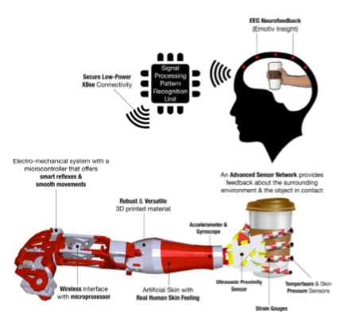

Figure 1. Mind-controlled smart prosthetic arm architecture

**2.1 Input Unit**

In this unit, brain signals are captured by an array of advanced EEG sensors communicating with a Signal Processing Unit via low-power and secure connectivity using Bluetooth technology. This device has an internal sampling rate of 2048Hz and 14 sensors arranged according to the international 10-20 System as shown in Figure 2 in order to cover the most relevant area over the brain. This allows a maximum and efficient coverage of the brain activity. EEG signals are acquired using the Emotiv EPOC wireless recording headset bearing 14 channels (AF3, F7, F3, FC5, T7, P7, O1, O2, P8, T8, FC6, F4, F8), referenced to the common mode sense [12].

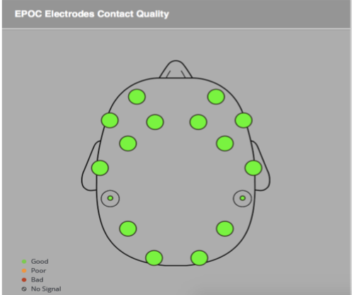

Figure 2. EEG 14-sensor arrangement

* 1. **Processing Unit**

The EEG signals provided by the input unit are sampled and processed on a lightweight wearable device – the Processing Unit. The processing activity consists of two main parts: a pattern recognition part that identifies different brain behavior captured by the input unit, and a command part that generates a series of commands to be sent to the mechatronics system of the arm. This unit is programmed to distinguish between several states of the mind representing different levels of “meditation” and “focus”. Every mind state is captured and encoded to represent a set of desired tasks to be performed by the arm. Due to the diversity and the complexity of brain wave activities among different humans, machine-learning techniques are required to train patients to specific arm movements according to a set of mind states.

* 1. **Electro-mechanical Unit**

This unit is designed and built from various lightweight high-strength materials that can handle high impacts and fragile elements as well. This unit integrates servos capable of handling 800 oz.-in. of stall torque. These servos are strategically placed to minimize hardware and facilitate complex moves. A microcontroller is also integrated to this setup to provide the interface between the Mechanical Unit and the Processing Unit. It can also be programmed to perform a series of predefined movements, allowing the arm to have a sophisticated and realistic real hand behavior.

* 1. **Interface Unit** – smart sensor network

This unit is composed of a network of smart sensors, including temperature, skin pressure and ultrasonic proximity sensors, accelerometers, potentiometers, strain gauges and gyroscopes. The main features of this unit allow the arm to interact with and adapt to the surrounding environment. Moreover, a bi-directional communication is required to give commands to the arm and provides feedback to the patient. This integrated network of sensors and actuators requires custom communication protocols and networking techniques that allow seamless interaction and control hand over between the arm and patient. By default, controlling the arm is handled by the brain (patient), however, it can be transferred to the arm to proactively protect itself against damage.

Due to its unique features, the proposed Mind-controlled Smart Prosthetic Arm should be able to improve the quality of life for millions of patients and their families around the world. Its low cost design will make it accessible to a wide range of beneficiaries, especially those with limited or no access to advanced health care.

**CHAPTER 3**

**TECHNICAL SPECIFICATIONS**

1. **Hardware overview**

The Smart Prosthetic Arm architecture is based on an advanced electro-mechanical system controlled by EEG neuro feedback technology.

This architecture is divided into 4 main units in terms of hardware (see Figure 3 and Figure 4):

- The *Data Sampling Unit* includes 14 EEG sensors implemented in the EEG-based headset. This unit converts EEG signals to digital signals and send them to the processing unit through Bluetooth communication channel. - The Wireless Communication Unit includes low power connection Bluetooth module interfaced with the Raspberry III microcomputer. This part implements a communication protocol between the user (EEG sensors installed on the head) and the embedded microcontroller in the prosthetic arm.

- The *Computing and Processing Unit*: Sampled EEG signals are channeled through the wireless communication unit to reach the Computing and Processing Unit, which is embedded in the arm and includes a Raspberry Pi III microcomputer, interfaced with an Arduino Mega microcontroller that handle the mechanical servo units installed in the arm. The main function of the processing unit is to treat the digitized EEG signals. It is programmed to compare between the headset reading and a set of premeasured patterns related to different states of the mind. Different mind states are captured and encoded to represent a set of desired tasks to be performed by the arm. This Unit is also programmed with multiple hand reflexes, triggered by the smart sensor network embedded in the arm. It gives the arm a human-like behavior via smooth movements and smart reflexes.

- Finally, *the Electro-Mechanical Unit* includes eight servos installed on the 3D designed model. The 3D hand model is built from various lightweight high-strength materials that can handle high impacts and fragile elements as well. This unit integrates all servos, which are capable of handling 800 oz.-in. of stall torque. It is embedded in the arm and links servos to joints to perform different motions. The servos are strategically placed to minimize hardware and facilitate complex moves. A microcontroller is also integrated to this setup to provide the interface between the Mechanical Unit and the Processing Unit.

Figure 3. System overview – block diagram

Control unit

Processing unit(BCI)

EEG Sensors

Placed on head

Bluetooth xbee

Mechanical unit

Sensor network

Block diagram with actual components.

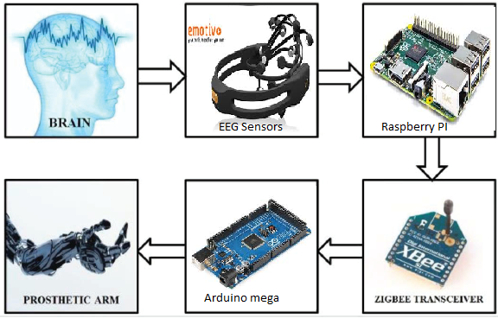

1. **Stages of operation of Brain Computer Interface**

This system can be broadly dived into four stages. These four stages are Signal detection, Signal acquisition, Signal transmission and Mapping Signal to Prosthetic arm.



Schematic outline of various stages involved in Brain Computer Interface

a. Signal Detection

This stage primarily targets at the careful detection of the EEG signal from the user scalp. Human brain consists of millions of neurons, each nerve cells connected to one another by dendrites and axons. Every time we think, feel, sense, move, or remember something, our neurons are at work. That task is carried out by small electric signals that zip from neuron to neuron as nimble as 250 mph. The signals are generated by differences in electric potential which are carried by ions on the membrane of individual neuron.

Detecting these signals can help interpret what they mean and use them to control a device of some kind. By placing electrodes or sensors on the scalp, it is possible to read and record the total electrical activity of the cerebral cortex using a methodology known as electroencephalography (EEG). EEG measures voltage fluctuations emerging from ionic current within the neurons of the brain. In the brain, there are millions of neurons, each of which creates small electric voltage fields. The aggregate of these electric voltage fields generates an electrical potential difference which electrodes on the scalp are able to detect and record. Therefore, EEG is the superposition of many elementary signals. The amplitude of an EEG signal typically ranges from about 1 μV to 100μV in a normal adult. EEG is generally described in terms of its frequency band. The elemental frequencies of the human EEG waves are: Delta, Theta, Alpha, Beta and Gamma.

Below Table shows the frequencies generated by different types of activities in the brain.

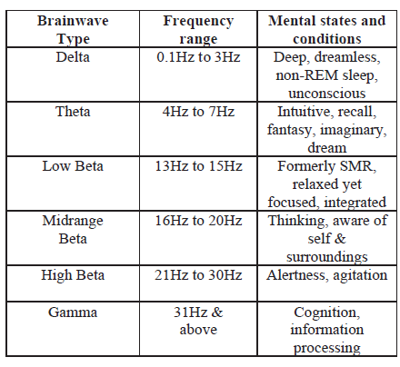

b.Signal Acquisition

The signals read by Emotive headset is sent to the raspberry pi via Bluetooth. The headset only detects, processes and converts the signal into digital form. The signal acquisition is done in raspberry pi processing system.

c. Signal Transmission

ZigBee

Signal transmission has to be done between the laptop and microcontroller. ZigBee is an IEEE 802.15.4- based specification for high-level wireless communication protocols. It is used to establish a personal area networks (PAN) with small, low-powered digital radios. Due to its low power consumption the transmission distances limits to 10–100 meters line-of-sight, subjected to power output and environmental characteristics. ZigBee has a defined transmission rate of 250 kbit/s. Its best suited for irregular data transmissions from a sensor or input device [10]. ZigBee is easy to implement and works with any kind of microcontroller. ZigBee is used for wireless communication between the processor and microcontroller. It

transmits the acquired EEG signals from processor to Arduino Uno.

d. Mapping Signal to Prosthetic Arm

The signal received from ZigBee transceiver has to be mapped to the prosthetic arm in the microcontroller (i.e. Arduino Mega). The received signal will act as command signal to control the prosthetic arm.

*1. Arduino Mega*

The Arduino Mega 2560 is a microcontroller board based on the ATmega2560. It has 54 digital input/output pins (of which 14 can be used as PWM outputs), 16 analog inputs, 4 UARTs (hardware serial ports), a 16 MHz crystal oscillator, a USB connection, a power jack, an ICSP header, and a reset button. It contains everything needed to support the microcontroller; simply connect it to a computer with a USB cable or power it with a AC to-DC adapter or battery to get started. The Mega is compatible with most shields designed for the Arduino Duemilanove or Diecimila. The Arduino software is easy-to-use for beginners, still acquiescent enough for advanced users. It runs on Mac, Windows, and Linux. The Arduino Uno is inexpensive, supports cross-platform, open source, easy programming environment.

*2. Prosthetic Arm*

The prosthetic arm structure can be 3D printed or built using metal. 3D printed arm will be cheaper than the metallic arm. Each finger will be individually connected to a servo motor. These 5 servo motors will help to control the movements i.e. flexion, extension and pinch. These three movements will be controlled by the command signal generated from Arduino Uno according to the brainwaves values received. Hence the prosthetic arm can be controlled using the command signal on a real time basis.

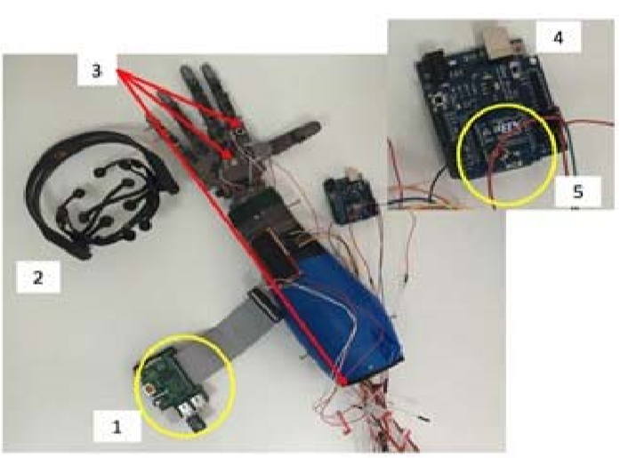

Figure 4. System overview – photo of the actual components

As shown in Figure 4 above, component number 1 is the processing unit that receives the EEG waves from the headset and communicates with the control unit; component number 2 is the Emotiv EEG headset with 14 sensors; component number 3 corresponds to the embedded sensors (temperature, proximity and touch); component number 4 is the control unit, which is Arduino based; component number 5 is the XBee driver (wireless communication with the processing unit).

1. **Power Consumption**

The power study of the proposed Smart Prosthetic Arm is divided into 2 major parts.

The EEG headset uses a lithium (Li) battery that provides up to 12 hours of continuous use when fully charged. If fully discharged (after 12 hours of usage), it can take up to 4 hours to be recharged. However, the charging process takes between 30 minutes to 2 hours when not fully discharged. Therefore, it is recommended to recharge it before 12 hours of continuous use. For safety reasons, the headset does not work while charging it.

The electro-mechanical system is composed of eight servo motors of rated power 0.5 Watts and 3.5 Watts, which are placed on different parts of the prosthetic arm (wrist, elbow, shoulder and fingers). Three servomotors with a rated power of 3.5 Watts are placed on the wrist, elbow and shoulder area to provide three degrees of freedom. In addition, five servomotors with a rated power 0.5 Watts each are used to control the five fingers. Thus, all the servomotors consume a total power of 13 Watts. A 5V battery with an output current of 2.6 Ampere is required to provide power to all servomotors embedded in the arm. The wireless communication unit operates when a 50 mA is supplied at 3.3 V, which requires a power of 0.165 Watts to operate.

In addition, a network of smart sensors is used, including temperature, skin pressure and ultrasonic proximity sensors, accelerometers, potentiometers, strain gauges and gyroscopes. These sensors consume a total current of 100 mA. The power consumption of the low-power single board computer (Computing and Processing Unit) is 0.1 Watts corresponding to a current of 30 mA. To power all the units listed above, the system requires a power source with an output current not less than 2.8 A and 5V as output voltage.

Two 10,000 mAh lithium ion batteries are chosen with an output current of 2A each. They include a charging circuit (via USB Cable), and a boost converter that provides 5V DC. These batteries have an 80% efficiency loss on both ends, meaning that it is not recommended to operate the arm while the battery is being charged. With these two batteries, the arm will be operational for 7 continuous hours knowing that the average hand movements per person during a day are equivalent to 1 to 3 hours of continuous movements depending on the daily activity performed. In conclusion, the whole system can be operational for 2 full days.

1. **Smart Sensors**

The sensors included in the proposed solution can be classified in two categories: user-end sensors and environmental sensors. The first category consists of the 14 EEG sensors presented previously which are installed on the user headset. As for sensors of the second category, their main feature is to allow the arm to interact and adapt to the surrounding environment, by providing intelligent feedback about critical condition, such as high temperature or pressure, etc. When interfaced with the embedded microprocessor installed on the arm, this network will give the prosthetic arm a human-like behavior with smart reflexes and smooth movements. Note that the feedback coming from some of these sensors will not only be used to operate some servos of the arm, but will also be displayed on small LCD screen mounted on the forearm.

1. **Control**

The proposed system is based on both fully autonomous and semi-autonomous control. A bi-directional communication channel is implemented between the smart sensor network and the embedded microprocessor in such a way to autonomously control the electro-mechanical unit and provide feedback to the user by displaying it on an LCD mounted on the arm.

This setup offers the arm the ability to have smart reflexes when it counters delicate, dangerous and critical situations such as protecting the arm from very hot surface contact or over squeezing fragile objects (glass, human hand, etc…). This integrated network of sensors and actuators requires custom communication protocols and control mechanisms techniques that allow seamless interaction and control hand over between the arm and the user. By default, the brain signals control the arm movements semi autonomously via a wireless connection.

The EEG headset has a proprietary wireless USB dongle that can be connected to the processing unit via a Bluetooth module. It reads the neuro electrical signals and interprets them as a set of predefined outputs that reflect facial expressions, mood and conscious intentions. These predefined outputs are received by the processing unit, compared with user-dependent library of pattern and then converted into functions. These functions are then labeled using variables and sent to the Arduino microcontroller through via UART channel. Based on these variables, a certain movement of the arm occurs according to the mapping that is done between the variables and the readings.

**CHAPTER 4**

**PRELIMINARY RESULTS**

During the training session performed, the signals corresponding to valence, engagement, frustration, meditation, short and long-term excitement detected by the Emotiv EPOC headset for 30 and 300 seconds are shown in Figure 5.

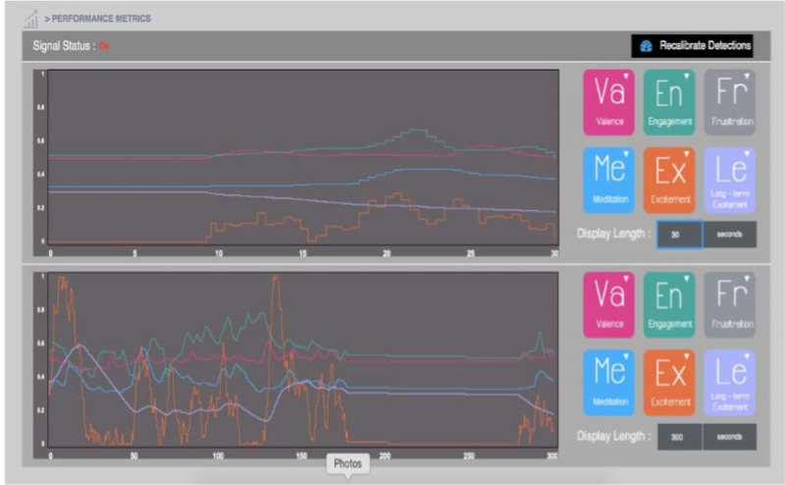

Figure 5. Different signals detected by the Emotiv headset

A 3D cube is displayed and a training session is available in order to guide the user to move the object using his cognitive thoughts as shown in Figure 6. The process starts by recording the user’s mind in neutral state. Then, the user can select an action (Left/Right) that he prefers to move the object.

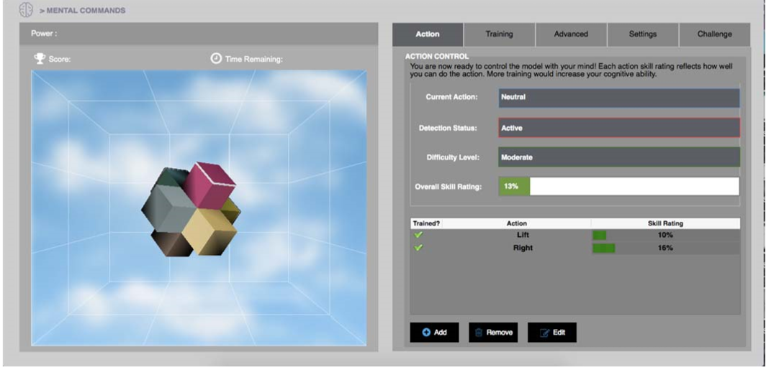

Figure 6. Training session with the 3D cube

Thinking of moving the cube to the left stimulates the set of servo motors placed on the prosthetic arm to close the hand (see Figure 7). Similarly, thinking of moving the cube to the right stimulates the hand to open (see Figure 8).

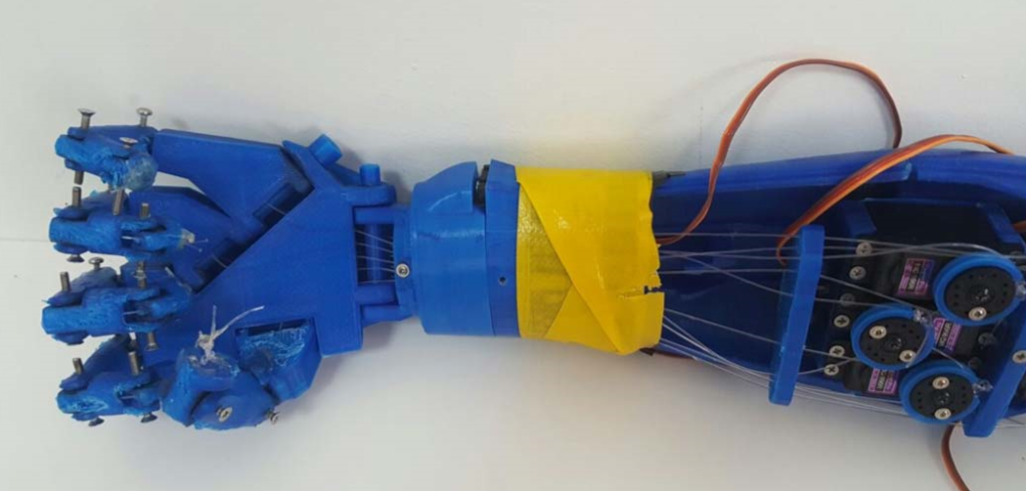

Figure 7. Prosthetic arm – closing hand

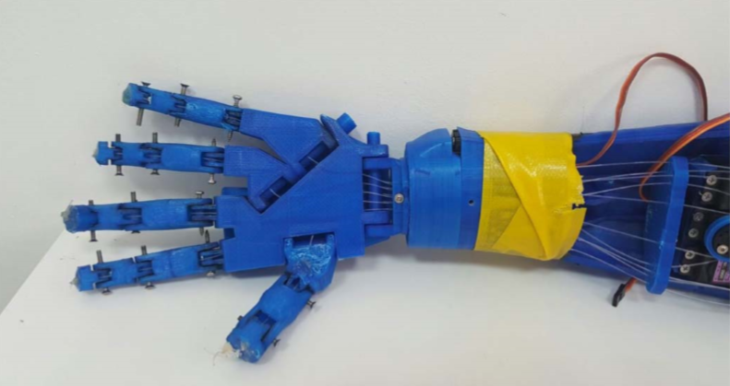

Figure 8. Prosthetic arm – opening hand

**CHAPTER 5**

**CONCLUSION**

The proposed arm hosts state-of-the art technological advancement, communication protocols, control systems, and human interfacing. This gives it great potential in many applications whether related to the health care field or not. On one hand, within health care, the idea could be expanded to other body parts as well as to patients having other dysfunctions as nerve damage. On the other hand, many industrial and commercial applications can utilize many features of the proposed arm. Within the health care field, there exists a class of patients who need extra help with their daily lives. This includes elderly people, people under rehabilitation, and people with limited mobility, etc. The proposed arm may be interfaced to a robotic-structure and function as a helper or caregiver to this group of people. It can be programmed to do various functions according to specific patient needs. This may vary from cooking to assistance with bathing or dressing. Another example in the medical field is remote high precision surgical procedures, where surgeons can undergo operations remotely with the aid of the robotic arm. Many industries employ robots in the manufacturing process, many of which can make use of a modified version of the proposed arm. Based on a specific application, this smart arm can be programmed to execute a series of predefined actions, and customized with dedicated sensors, actuators and customized algorithms (such as image and signal processing, gesture and voice recognition etc…). In addition, connecting the arm to the Internet, and making it part of an Internet of Things network (IOT) will increase the performance and productivity of many industry applications. A first prototype is designed, built and is under test. The testing requires long training sessions in order first to build a user dependent library of brain activity patterns, and second to make the user more familiar and comfortable using this hand.

**REFERENCES**

[1] S. W. Hawking, “World report on disability,” World Health Organization, Geneva, Switzerland, 2011.

[2] NBC News. (2010, March 20). Limb loss a grim, growing global crisis [Online].Available: http://haitiamputees.nbcnews.com/_news/2010/03/19/4040341-limbloss-a-grim-growing-global-crisis

[3] M. LeBlanc. (2011, January 14). Give Hope – Give a Hand [Online]. Available: <https://web.stanford.edu/class/engr110/Newsletter/lecture03a2011.html>

[4] C. Moreton. (2012, August 4). London 2012 Olympics: Oscar Pistorius finally runs in Games after five year battle [Online]. Available:

<http://www.telegraph.co.uk/sport/olympics/athletics/9452280/London2012-Olympics-Oscar-Pistorius-finally-runs-in-Games-after-five-yearbattle.html>

[5] Y. Jeong, D. Lee, K. Kim and J. Park, “A wearable robotic arm with high force-reflection capability,” in 9th IEEE International Workshop on Robot and Human Interactive Communication, Osaka, 2000, pp. 411-416.

[6] A. Bennett Wilson Jr., B. (n.d.). Retrieved October 17, 2015, from oandplibrary: <http://www.oandplibrary.org/alp/chap01-01.asp>

[7] E. Sofge (2012, May 28). Smart Bionic Limbs are Reengineering the Human. [Online]. Available:<http://www.popularmechanics.com/science/health/a7764/smart-bioniclimbs-are-reengineering-the-human-9160299>

[8] R. M. Coupland, War Wounds of Limbs: surgical management. Geneve, Switzerland, ICRC, 1993.

[9] Jerkey. Brain-Controlled Wheelchair [Online]. Available:

<http://www.instructables.com/id/Brain-Controlled-Wheelchair>

[10] H. Heyrman. Brainwaves [Online]. Available:

<http://www.doctorhugo.org/brainwaves/brainwaves.html>

[11] S. Sequeira, C. Diogo and F.J.T.E. Ferreira, “EEG-signals based control strategy for prosthetic drive systems,” in IEEE 3rd Portuguese Meeting in Bioengineering, Braga, 2013, pp. 1-4.

[12] V. Charisis, S. Hadjidimitriou, L. Hadjileontiadis, D. Ugurca and E. Yilmaz, “EmoActivity – An EEG-based gamified emotion HCI for augmented artistic expression: The i-Treasures paradigm,” in Springler Verlag Berlin Heidelberg, Berlin, 2011.

[13] S. K. Al Kork, "Development of 3D finite element model of human elbow to study elbow dislocation and instability," in ASME 2009 Summer Bioengineering Conference, American Society of Mechanical Engineers, 2009.

[14] T. Beyrouthy and L. Fesquet, “An event-driven FIR filter: design and implementation,” in 22nd IEEE International Symposium on Rapid System Prototyping (RSP), May 2011, pp. 59-65.